OUTPUT SCREEN:

1.HOTEL MANAGEMENT PROJECT:

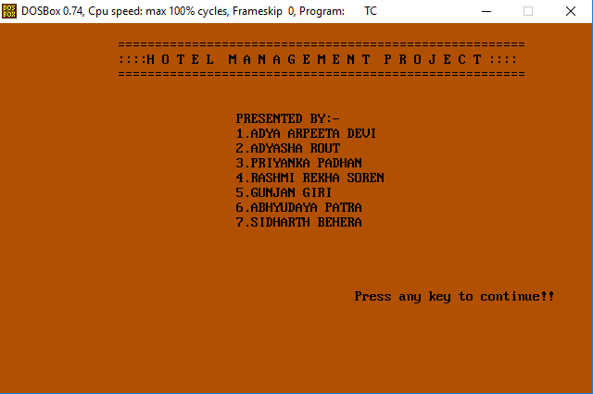

2.MAIN MENU:

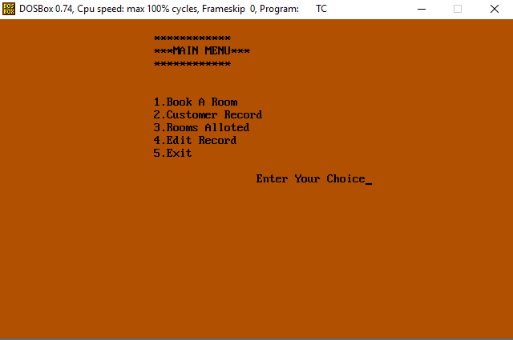

3.BOOKING A ROOM:

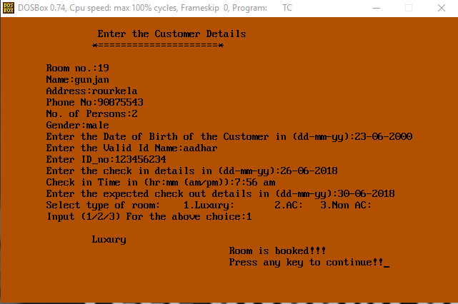

4.CUSTOMER DETAILS:

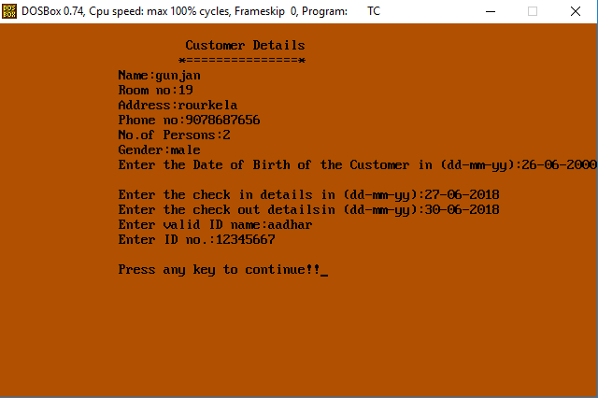

5.LIST OF ROOMS ALOTTED:

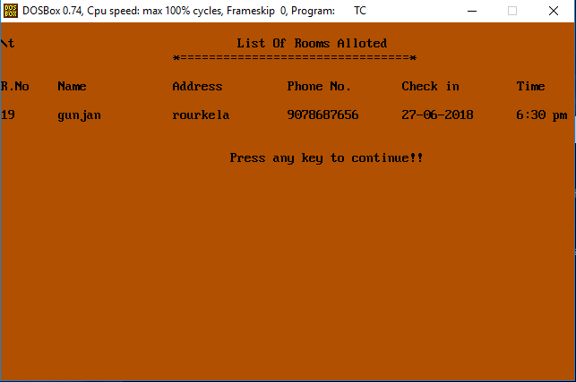

6.MODIFY THE CUSTOMER’S RECORDS:

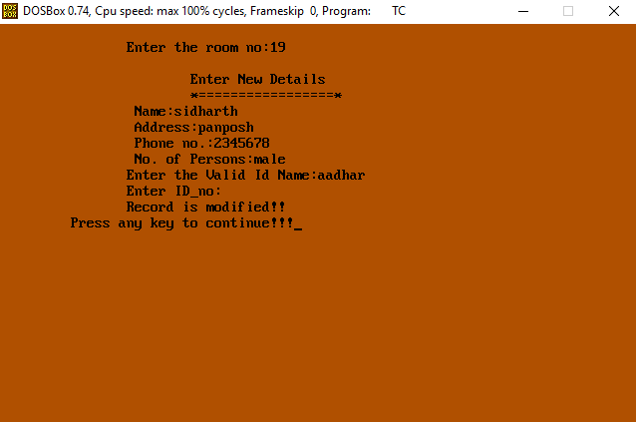

7.DELETE RECORD:

